**DAILY ONLINE ACTIVITIES SUMMARY**

|  |  |  |  |  |  |  |  |  |
| --- | --- | --- | --- | --- | --- | --- | --- | --- |
| **Date:** | **28/05/2020** | | | | | **Name:** | **Manish B Shriyan** | |
| **Sem & Sec** | **8th sem B sec** | | | | | **USN:** | **4AL16CS131** | |
| **Online Test Summary** | | | | | | | | |
| **Subject** | | **SMS** | | | | | | |
| **Max. Marks** | | **60** | | **Score** | | | **51** | |
| **Certification Course Summary** | | | | | | | | |
| **Course** | **AWS Security Fundamentals(Second Edition)** | | | | | | | |
| **Certificate Provider** | | | **AWS** | | **Duration** | | | **2 Hour** |
| **Coding Challenges** | | | | | | | | |
| **Problem Statement:**  **Given an array arr[] of size N and an integer K. The task is to find the last remaining element in the array after reducing the array. The rules for reducing the array are: The first and last element say X and Y are chosen and removed from the array arr[].** | | | | | | | | |
| **Status: Solved** | | | | | | | | |
| **Uploaded the report in Github** | | | | | **Uploaded** | | | |
| **If yes Repository name** | | | | | **ManishShriyan** | | | |
| **Uploaded the report in slack** | | | | | **Yes** | | | |

Online Test Details:

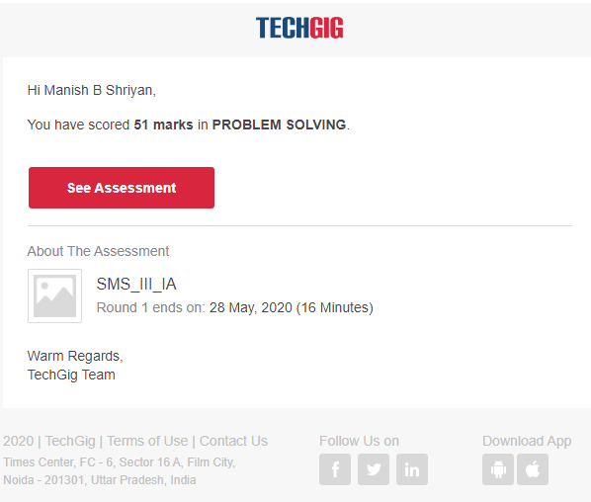

Certification Course Details:

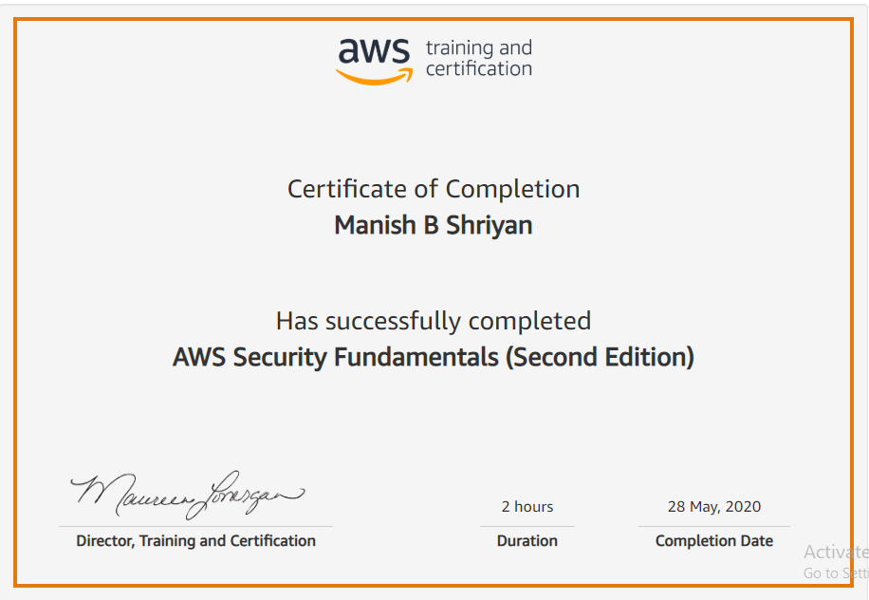

Coding Challenges Details:

|  |
| --- |
| #include<stdio.h> |
|  | #include<conio.h> |
|  |  |
|  | int main() |
|  | { |
|  | int n, k, arr[10], sum = 0; |
|  |  |
|  | printf("Enter the value of n: "); |
|  | scanf("%d",&n); |
|  |  |
|  | printf("Enter the %d numbers: ", n); |
|  | for (int i = 0; i < n; i++) { |
|  | scanf("%d", &arr[i]); |
|  | } |
|  |  |
|  | printf("Enter the value of k: "); |
|  | scanf("%d",&k); |
|  |  |
|  | for (int i = 0; i < n; i++) { |
|  | sum += arr[i]; |
|  | } |
|  | sum = sum % k; |
|  | printf("%d", sum); |
|  | return 0; |
|  | } |